History of C Language

**History of C language** is interesting to know. Here we are going to discuss a brief history of the c language.

**C programming language** was developed in 1972 by Dennis Ritchie at bell laboratories of AT&T (American Telephone & Telegraph), located in the U.S.A.

**Dennis Ritchie** is known as the **founder of the c language**.

It was developed to overcome the problems of previous languages such as B, BCPL, etc.

Initially, C language was developed to be used in **UNIX operating system**. It inherits many features of previous languages such as B and BCPL.

Let's see the programming languages that were developed before C language.

|  |  |  |
| --- | --- | --- |
| **Language** | **Year** | **Developed By** |
| Algol | 1960 | International Group |
| BCPL | 1967 | Martin Richard |
| B | 1970 | Ken Thompson |
| Traditional C | 1972 | Dennis Ritchie |
| K & R C | 1978 | Kernighan & Dennis Ritchie |
| ANSI C | 1989 | ANSI Committee |
| ANSI/ISO C | 1990 | ISO Committee |
| C99 | 1999 | Standardization Committee |

# Features of C Language

C is the widely used language. It provides many **features** that are given below.

1. Simple
2. Machine Independent or Portable
3. Mid-level programming language
4. structured programming language
5. Rich Library
6. Memory Management
7. Fast Speed
8. Pointers
9. Recursion
10. Extensible

## **1) Simple**

C is a simple language in the sense that it provides a **structured approach** (to break the problem into parts), **the rich set of library functions**, **data types**, etc.

## **2) Machine Independent or Portable**

Unlike assembly language, c programs **can be executed on different machines** with some machine specific changes. Therefore, C is a machine independent language.

## **3) Mid-level programming language**

Although, C is **intended to do low-level programming**. It is used to develop system applications such as kernel, driver, etc. It **also supports the features of a high-level language**. That is why it is known as mid-level language.

## **4) Structured programming language**

C is a structured programming language in the sense that **we can break the program into parts using functions**. So, it is easy to understand and modify. Functions also provide code reusability.

## **5) Rich Library**

C **provides a lot of inbuilt functions** that make the development fast.

## **6) Memory Management**

It supports the feature of **dynamic memory allocation**. In C language, we can free the allocated memory at any time by calling the **free()** function.

## **7) Speed**

The compilation and execution time of C language is fast since there are lesser inbuilt functions and hence the lesser overhead.

## **8) Pointer**

C provides the feature of pointers. We can directly interact with the memory by using the pointers. We **can use pointers for memory, structures, functions, array**, etc.

## **9) Recursion**

In C, we **can call the function within the function**. It provides code reusability for every function. Recursion enables us to use the approach of backtracking.

## **10) Extensible**

C language is extensible because it **can easily adopt new features**.

## What is C programming?

**C** is a general-purpose programming language that is extremely popular, simple and flexible. It is machine-independent, structured programming language which is used extensively in various applications.

C was the basic language to write everything from operating systems (Windows and many others) to complex programs like the Oracle database, Git, Python interpreter and more.

It is said that 'C' is a god's programming language. One can say, C is a base for the programming. If you know 'C,' you can easily grasp the knowledge of the other programming languages that uses the concept of 'C'

It is essential to have a background in computer memory mechanisms because it is an important aspect when dealing with the C programming language.

[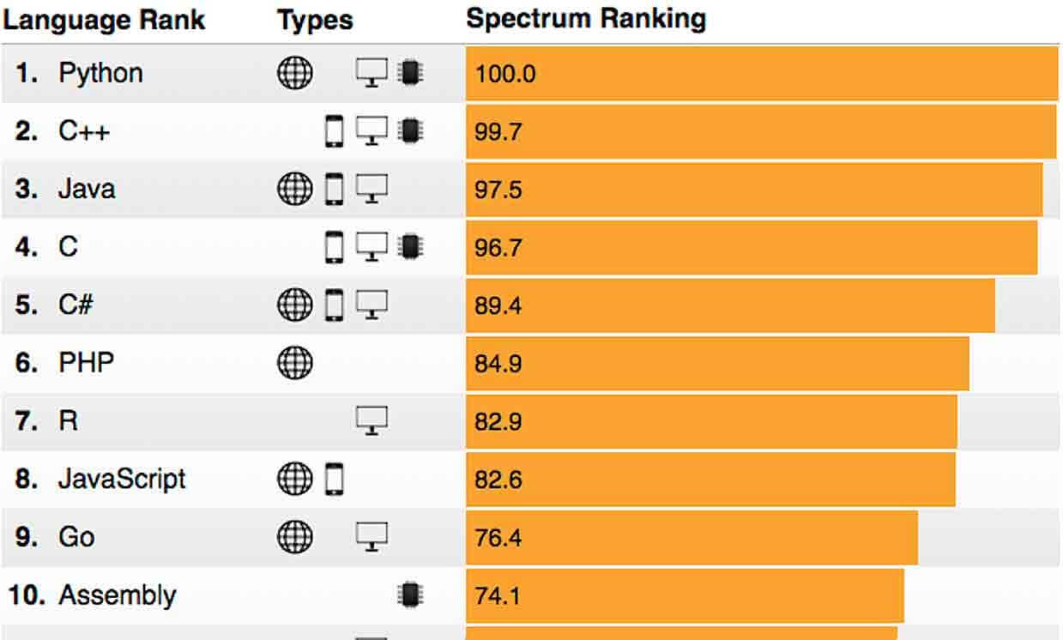](https://www.guru99.com/images/1/012419_1229_WhatisCProg1.jpg)IEEE-the best 10 top programming language in 2018

## History of C language

The base or father of programming languages is 'ALGOL.' It was first introduced in 1960. 'ALGOL' was used on a large basis in European countries. 'ALGOL' introduced the concept of structured programming to the developer community. In 1967, a new computer programming language was announced called as 'BCPL' which stands for Basic Combined Programming Language. BCPL was designed and developed by Martin Richards, especially for writing system software. This was the era of programming languages. Just after three years, in 1970 a new programming language called 'B' was introduced by Ken Thompson that contained multiple features of 'BCPL.' This programming language was created using UNIX operating system at AT&T and Bell Laboratories. Both the 'BCPL' and 'B' were system programming languages.

[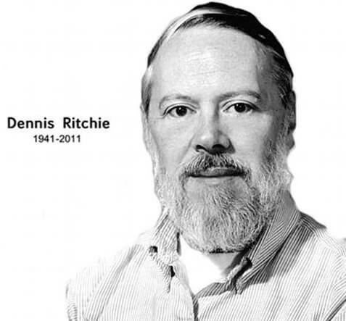](https://www.guru99.com/images/1/012419_1229_WhatisCProg2.jpg)

In 1972, a great computer scientist Dennis Ritchie created a new programming language called 'C' at the Bell Laboratories. It was created from 'ALGOL', 'BCPL' and 'B' programming languages. 'C' programming language contains all the features of these languages and many more additional concepts that make it unique from other languages.

'C' is a powerful programming language which is strongly associated with the UNIX operating system. Even most of the UNIX operating system is coded in 'C'. Initially 'C' programming was limited to the UNIX operating system, but as it started spreading around the world, it became commercial, and many compilers were released for cross-platform systems. Today 'C' runs under a variety of operating systems and hardware platforms. As it started evolving many different versions of the language were released. At times it became difficult for the developers to keep up with the latest version as the systems were running under the older versions. To assure that 'C' language will remain standard, American National Standards Institute (ANSI) defined a commercial standard for 'C' language in 1989. Later, it was approved by the International Standards Organization (ISO) in 1990. 'C' programming language is also called as 'ANSI C'.

[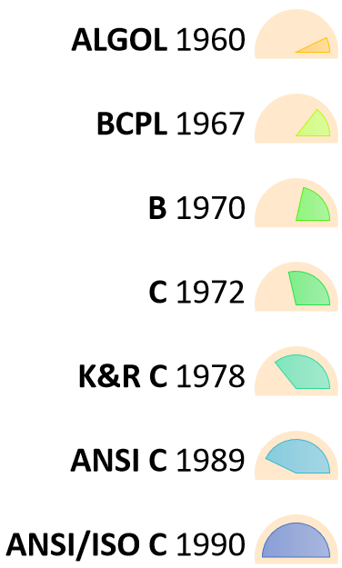](https://www.guru99.com/images/1/012419_1229_WhatisCProg3.png)History of C

Languages such as C++/Java are developed from 'C'. These languages are widely used in various technologies. Thus, 'C' forms a base for many other languages that are currently in use.